**Movements of the deep-water snapper *Pristipomoides filamentosus* with respect to a network of restricted fishing areas.**

**Stephen R. Scherrer1, Kevin C. Weng2**

1Department of Oceanography, University of Hawaii at Manoa, Honolulu, Hawaii, USA

2 Virginia Institute of Marine Science, College of William & Mary, Gloucester Point, Virginia, USA

Corresponding author:

Stephen R. Scherrer

1000 Pope Road, MSB 609, Honolulu, Hawaii, 96822, USA

Email address: Scherrer@hawaii.edu

**Abstract (200 words max)**

In an attempt to curb overfishing of key deep-water bottomfish species in the Hawaiian archipelago, managers established a network of restricted fishing areas throughout the fishery. There is a paucity of information regarding the spatial ecology of these fish in relation to these areas. We implanted 179 *Pristipomoides filamentosus,* a key species in this fishery, with acoustic tags to track the long-term spatial use around one of these areas between June 2017 and April 2018.

Only 10 individuals appeared to have survive more than 14-days post-tagging, likely due to predation and barotrauma. The scale of movements observed for these individuals (median maximum distance = 4.6-km, 1st quantile = 3.2-km, 3rd quantile = 7.2-km) compared favorably to the scale of spatial protections (median linear habitat dimension = 14.7-km, 1st quantile = 10.7-km, 3rd quantile = 19.1-km). Fish crossed protective borders, on average, 0.02 times per day (s.d. = 0.03) or once every 43.2-days. These results indicate that spatial protections, as enacted, are likely to sufficient to provide positive benefits to fish within their borders.

**Introduction**

Deep-water demersal fishes are a valuable economic and cultural resource throughout the Indo-Pacific. In Hawaii, commercial and recreational bottomfish fisheries use hook-and-line methods to target a multispecies complex of demersal fishes that inhabit the archipelago’s slopes and banks at depths between 100 and 400-m (Polovina et al., 1985). During the 2017-2018 fishing year, the ex-vessel value of these species was in excess of 1.6 million dollars[1].

Management of bottomfish resources is a partnership of federal and state agencies and focuses on six species of eteline snapper and one endemic grouper (Anonymous 2009). Locally these species are referred to as the Deep 7 and include *Pristipomoides filamentosus* (local name ‘opakapaka’), the species representing the highest catch abundance, followed by *Etelis courscans* (‘onaga’), *Etelis carbunculus* (‘ehu’), and *Pristipomoides sieboldii* (‘kalekale’). *Aphareus rutilans* (‘lehi’), *Pristipomoides zonatus* (‘gindai’), and the endemic Hawaiian grouper *Hyporthodus quernus* (‘hapuupuu’) make up the remainder of the seven managed species (Martell, Christensen, and Zeller, 2006).

In response to the declining spawning potential ratio for *E. carbunculus* and *E. courscans*, an annual catch limit and a network of areas where fishing was restricted were introduced in 1998. These control measures were meant to facilitate the recovery of Deep 7 stocks. The Bottomfish Restricted Fishing Areas, or BRFAs as they are known, were designed to protect 20% of bottomfish habitat in the Main Hawaiian Islands (MHI), and to reduce total mortality by 15% (National Marine Fisheries Service, 2006). In 2008 the BRFAs were restructured, with a goal of further reducing fishing pressure. Incorporated in this revision process was improved knowledge of preferred bottomfish habitat. The number of protected areas was also reduced from 19 to 12.

The BRFAs are controversial among fishery stakeholders (Hospital and Beavers, 2011) and in recent years some bottomfish fishers have lobbied managers to do away with some or all of the areas (Western Pacific Regional Fishery Management Council, 2013). NOAA, The State of Hawaii’s Department of Land and Natural Resources, and the federal Western Pacific Regional Fishery Management Council, who jointly manage bottomfish resources in Hawaii, require information on the movement of bottomfish to inform the future of these management strategies (Western Pacific Regional Fishery Management Council, 2014).

The BRFAs and similar Marine Protected Areas operate under the assumption that fishing mortality can be reduced by excluding fishers from specific zones. However, protected areas may fail to meet management objectives if they are of insufficient size, such that fish routinely journey into unprotected waters. On the other hand, protection at very large scales may negatively impact people reliant on these resources, either financially or for sustenance (Kramer and Chapman, 1999; Botsford, Micheli, and Hastings, 2003; O’Dor et al., 2004; Sale et al., 2005). Understanding how component species interact with and benefit from closed areas and if these areas are of a size sufficient while minimizing fisher displacement are questions of critical importance.

There is presently little empirical data to assess how the spatial scale of the BRFAs compares to the routine movements of the fish they are intended to protect (Western Pacific Regional Fishery Management Council, 2014). Coarse estimates of movement potential *for P. filamentosus* have been obtained through mark-release-recapture tagging studies. An ongoing cooperative tagging program between NOAA and the Pacific Islands Fisheries Group recaptured *P. filamentosus* (n = 111, median time at liberty = 325 days) up to 61-km from their tagging location, however most individuals appeared to move at limited scales with 86% of recovered tags recovered less than 10-km from their tagging site (O’Malley, 2015). These observations are supported by surveys conducted with underwater baited stereo cameras that found evidence of larger body size in target species inside BRFAs, consistent with individuals deriving protection from the BRFA (Sackett et al., 2014).

A handful of studies have used acoustic tracking to study the Deep 7. Moffitt and Parrish (1996) used active tracking to follow 2 juvenile *P. filamentosus* over periods of 5-6 days each. They noted crepuscular movements between day and night habitat. Ziemann and Kelly used passive acoustic telemetry to track *P. filamentosus* in 2004 (n = 12, median time at liberty = 5.80-days, 5 receiver array), 2006 (n = 5, median time at liberty = 0.21-days, 3 receiver array), and again in 2007 (n = 10, median time at liberty = 0.58-days, 7 receiver array) and reported diurnal movements and spillover from the Kahoolawe Island Reserve (Ziemann and Kelley, 2004, 2007, 2008). Weng (2013) passively tracked *E. carbunculus* (n = 6, median time at liberty = 28.44-days, 8 receiver array) and *E. courscans* (n = 12, median time at liberty = 40.83-days, 8 receiver array) off the island of Niihau and found that the majority of individuals spent the most of their time within the protected area of the BRFA. All of these studies used small tracking arrays, tagged small numbers of fish, and had short track durations. Therefore, long-term and fine scale movement patterns remain poorly understood and the degree of protection provided by BRFAs is unclear (Oishi and Devick, 2000; Weng, 2013; O’Malley, 2015).

The goal of this study was to investigate spatial and temporal use of one of these BRFAs by *P. filamentosus* using passive acoustic telemetry. We investigated the frequency at which individuals were observed moving between protected and non-protected habitat using an array of 38 receiver stations located within and outside the boundaries of the restricted fishing area. We also calculated observed home range sizes and compared these estimates to the habitat available within the 12 BRFAs.

**Materials and Methods**

*Study area*

The Makapuu region (21° 33.5 N, 157° 52.5 W) was selected as the study site for this project because it contains both protected (BRFA-E) and non-protected habitat with sufficient area to capture the scale of bottomfish movements observed on a previous multi-island array. The area is important to the commercial fishery and in close proximity to a number of ports frequented by bottomfish fishers.

The area is located off Oahu’s windward side, and extends outward from Makapuu Point, the south east tip of the island of Oahu, north to the Lanikai Peninsula. A flat broad shelf protrudes east from the island’s southern edge before terminating in a deep slope that forms the western side of the Kaiwi Channel. The shelf narrows to the north joining with a series of deeper shelves and forms submarine canyons. BRFA-E extends from 1.5-miles offshore westward across the shelf in line with Koko Head crater to the south and Kailua to the north (Figure 2). The adult bottomfish habitat area with BRFA-E, defined as the area between the 100 and 400-m depth contours (Parke, 2007), is approximately of 49-km2.

*Receiver array design*

The tracking array comprised 43 individual receiver stations. Each station consisted of an acoustic receiver (VR2-W or VR2-AR, Vemco Ltd, Halifax, Nova Scotia, Canada[2]) and acoustic release (VR2-AR, Vemco Ltd, Halifax, Nova Scotia, Canada or LRT, Sonardyne International Ltd, Yateley, Hampshire, UK) buoyed by three or four trawl floats and moored to the seafloor with approximately 80-kg of concrete blocks. Each mooring line was sheathed inside a 1.5-inch diameter PVC tube to minimize the potential for entanglement or fraying.

The tracking array was made up of two kinds of sub-array with differing roles, 'fence' and 'sparse' sub-arrays (Figure 1). A ‘fence’ sub-array is a line of receivers deployed with overlapping detection regions so that a tagged fish transiting the ‘fence’ will be detected. The fences were designed to detect movement across BRFA borders. Because a fence placed on the border would detect fish that were resident either inside or outside and near the border, it was necessary to have two fences – one outside the BRFA at a distance from the border that was greater than the detection range, and another inside the BRFA. Two pairs of receiver fences were deployed, one at the southern border and another at the northern border (four fences in total). Placement of receiver fences was optimized with respect to the receiver’s probability of detecting a tag transmission over a range of horizontal distances, the bathymetry along the fence’s transect, the height of the receiver off the seafloor, desired height of the water column to monitor, the swimming speed of the species, and the minimum acceptable detection rate of the fence.

A ‘sparse’ sub-array is a group of receivers with non-overlapping detections regions, placed to detect movements around a region, but allowing for much of the region to be unmonitored. The sparse sub-array area monitored movement between areas within the BRFA. Individual receiver positions within the sparse sub-array were determined in iterative stages using the Acoustic Web App telemetry optimization algorithm (Pedersen, Burgess, and Weng, 2014) and 50-m and 1-km bathymetry sources (Johnson and Potemra, 2011; Smith, 2016). Sparse sub-array deployment locations were selected within the bounds of BRFA-E after constraining depth between 75 and 475-m. Aggregations of up to 100 *P. filamentosus* have been reported 2–10-m above the seafloor around the Penguin Banks area (Haight, 1989; Haight, Kobayashi, and Kawamoto, 1993; Kelley and Moriwake, 2012), so a preferred depth above the seafloor of 6-m was selected. A maximum receiver detection range of 847-m was specified using results from a deep-water range test we have previously reported (Scherrer et al., 2018).

The probabilities of detecting tag transmissions across a range of distances were determined through range testing experiments. Results of ranging experiments showed that 5% of tag transmissions could be heard at a distance of 847-m from the receiver. 12.5% of tag transmissions were detectable at a distance of 765-m and 25% of tag transmissions were detectable at a distance of 545-m (Scherrer et al, 2018). Therefore, to achieve a 12.5% detection rate, spacing between any two subsequent receivers in a fence configuration should not exceed 1530-m. To be conservative, the fence algorithm was initialized with a 12.5% detection range of 600-m and a 25% detection range of 500-m. Receiver stations were released from the vessel when it was at the target location and were allowed to sink freely to the seafloor. Using the position of the vessel at the time of deployment as the station’s position, the largest distance between two receivers in any of the fence configurations was 1025-m, well within the minimum 1530-m spacing requirement.

Receivers in relatively deep water are particularly susceptible to close proximity detection interference (CPDI), a phenomenon where a receiver may fail to detect transmissions from tags at close distances (Kessel et al., 2015; Scherrer et al., 2018). Results from predictive modeling indicate that CPDI was likely a factor for receivers at depths exceeding 200-m. However, CPDI is not believed to have affected the ability of receiver fence sub-arrays to detect fish transiting through them as multiple transmissions would be sent by a tagged fish while within the detection range of the receiver and before the region affected by CPDI was encountered.

Two receiver stations from the fence sub-arrays were lost during the course of the study (Figure 2). Station 323 from the northern boundary fence inside the BRFA (325-m depth) monitored habitat between 200 and 450-m. Losing this station truncated the fence with the 25% minimum detection threshold extending only to an approximate depth of 370-m rather than 400-m as planned. Station 340 (324-m depth) was lost from the southern boundary fence inside the BRFA where it monitored habitat ranging in depth from 220 to 330-m. Adjacent receivers within the BRFA’s inside southern fence were approximately 977-m apart and had internal tags comparable to those used for tagging *P. filamentosus*. The loss of this station reduced the fence’s detection ability. Prior to the loss of the station, individual transmissions from the unrecovered receiver’s internal tag were detected at either adjacent receivers located to the east and west at daily rates ranging between 0.6 and 6.9% (Median = 3.4%, 1st IQR = 1.7%, 3rd IQR = 4.5%). The possibility that a tagged *P. filamentosus* could traverse the southern fence located within the BRFA undetected by adjacent receivers cannot be ruled out.

*Fish Capture and Tagging*

Fish in this study were captured with the assistance of bottomfish fishers using vertical deep drop hook and line gear and hydraulic or electric line pullers. Kaka line and mak-e dog rigs are the most common method of bottomfishing in the Hawaiian archipelago and were used to land fish during this study (Glazier, 2007). Hooks were baited with squid, anchovies, sardines, and/or saury for bait. Kaka line rigs were fished with no more than 6 baited hooks at a time. Palu is an attractant consisting of finely chopped bait and sometimes a filler material such wheat chaff, rice, or oats and was released when the rig was at fishing depth to attract and aggregate bottomfish. To reduce mortality in this study, when possible, the rate at which the mainline was pulled when a fish was hooked was slowed to facilitate some compensative off gassing of the swim bladder during ascent while still pulled at a rate fast enough to limit predation.

Fish were brought aboard the vessel for surgical tagging and then immediately released back to the wild. Once aboard the vessel, the hook was removed from the fish’s mouth. Fish that were deemed acceptable for tagging were placed ventral side up in a padded v-board cradle. Sea water was pumped over the gill surface using a saltwater hose or a recirculating pump to provide the fish oxygen. If symptoms of barotrauma were present and severe, they were relieved by venting the fish’s swim bladder or protruding stomach with a sterile 18-gauge hypodermic needle. An incision between 1.5 and 2.5-cm in length was made with a sterile scalpel along the fish’s ventral centerline a few cm anterior to the vent. An acoustic tag was inserted into the peritoneal cavity with triple antibiotic cream. The incision was closed using sutures (Ethicon PDS&Plus antibacterial monofilament) and secured with a surgeon’s knot. When dart tags were available (4-inch PDS-2, Hallprint PTY Inc, Hindmarsh Valley, South Australia), fish were tagged externally between the lateral line and the dorsal fin. Dart tags were provided by the Pacific Islands Fisheries Group as part of a long-term mark-recapture program. On-deck handling times were typically less than 5-minutes.

Two types of acoustic tag were used in the study, one with a depth sensor and one without. Each acoustic tag transmitted a uniquely coded ultrasonic identifier once every 90 to 200-seconds (nominal transmission interval 145-seconds). V13 transmitters had an expected battery life of 2.25-years and provided presence data, while V13P tags had an expected battery life of 1.63 years and provided both presence and depth data.

To select the size range of fish suitable for tagging, V13 (non-depth recording) and V13P (depth recording) tags were weighed. The minimum size of *P. filamentosus* eligible for tagging with each type of tag was determined using a conservative 2% of bodyweight threshold and a species specific allometric relationship between fork length and weight (Uchiyama and Kazama, 2003). For our tags, the minimum fork length *P. filamentosus* that could be tagged was 14-cm for V13 tags and 15-cm for V13P tags.

Four strategies for release were used in an attempt to balance rapid recompression and predator avoidance. (1) Release at the seafloor using a drop shot device (Blacktip Brand, 58 individuals), (2) midwater release (30—60-m) using a drop shot device (Seaqualizer Brand, 70 individuals), (3) surface/near surface release (16 individuals), and (4) driving the vessel rapidly away from the fishing location before release using the drop shot device (xx individuals). The method of release was not recorded for 2 individuals.

To directly assess the impact of barotrauma and surgery on *P. filamentosus*, we built a mid-water net-pen (approximately 1.5-m high, 2.5-m diameter) and used it to hold a tagged *P. filamentosus* at 20-m depth following capture and surgery (n=4 individuals). After 30-60 minutes we descended to the net-pen using SCUBA and observed the fish, noting condition and ability to orient and maintain neutral buoyancy. We then opened the net pen, allowing the fish to swim free and observed its swimming ability.

*Categorizing Fish Status*

An algorithmic process was developed to determine the status of fish detected on the receiver based on features of their tracks (Figure 3). High post-release mortality and moderate to high rates of single station residency observed in tagged fish make determining fish status non-trivial. Simply, it is difficult to distinguish a tagged fish that has died and who’s tag is lying on the bottom near a receiver from a tagged fish that is alive and has a small home range near a receiver. Our algorithm assigned tracks to one of three categories: expired tracks from fish that are dead, valid tracks from fish believed to be alive, and uncertain tracks in which a track could not be determined. Following classification, we reviewed records of each tag and made adjustments to assigned status where appropriate.

It is similarly difficult to distinguish a rapidly moving tagged fish from a shark that has eaten a tagged fish, so we tagged several predator species to assist in designing and parameterizing the classification algorithm. We tagged 8 sandbar sharks (*Carcharhinus plumbeus*), one silky shark (*Carcharhinus* *falciformis*), and one Galapagos shark (*Carcharhinus galapagensis*). All tagged sharks were detected on the receiver array during the analysis period. The movement pattern exhibited by these predators was characterized by frequent movement between stations (mean movements per day = 10.82, standard deviation [s.d.] = 14.65), detection at multiple stations in a single day (mean stations detected per day: 3.5, s.d. = 1.7), and movement over large distances (mean linear home range = 17.27, s.d. = 7.17). These 'shark-like' qualities were used as indication of a predation event (when an *P. filamentosus* tag showed a pattern like these sharks). Because a meal eaten by a predator is likely to be digested and the tag regurgitated within about one week (citations), we doubled this time period to be conservative, and discarded all tracks shorter than 14 days (as these might be *P. filamentosus* that are inside a shark’s stomach) (Medved, 1985). Tags belonging to fish consumed by predators exhibited 'shark-like' detection patterns for a period of 1-14 days followed by cessation of movement. The 'shark-like' movement period is thought to correspond to the time when the tagged fish was in the stomach of a predator, while the cessation of movement is thought to be the period after the predator has regurgitated the tag. Based on the sharks instrumented with acoustic tags, we defined 'shark-like' movement as detection at 4 or more stations during the first 14 days of the track. Predation/mortality status could not be determined for tags with tracks less than 14-days.

Further classification was based on horizontal movement. Range testing indicated that under the optimal conditions, tag transmissions could be detected by receivers up to a distance of 1000-m, so detections on two receivers that are <2 km apart could be from a stationary tag laying on the bottom. Therefore, fish with tracks that moved between two stations separated by more than 2000-m after the 14th day post-tagging were considered valid.

If no movement was observed between stations, status could be further classified for individuals with tags capable of reporting depth. Following the 14th day, a valid status was assigned to tracks from individuals with depth-sensing tags where vertical movement range exceeded 10-m. This threshold was selected as it is greater than the maximum fluctuation in depth that could be explained by tidal changes alone.

Tags lacking depth sensors that did not move after 14 days were classified as dead if they had a strong shark-like movement pattern at the beginning of the track. The status of a fish detected at fewer than 4 stations during the first 2-weeks of the track was uncertain. Visual inspection of tracks belonging to these fish were indistinguishable from stationary tags belonging to fish that were known to be dead while also resembling highly resident fish that were known to be alive from depth records. This group tags with an uncertain status likely includes a mixture of both valid tracks from highly resident fish that were detected consistently at a single receiver and detections of stationary tags belonging to fish that expired after they were tagged.

*Testing for size selective survivorship bias*

Correlation between body size and survivorship outcome for tagged *P. filamentosus* was tested by comparing the distribution of fork lengths from fish with valid tracks to the total population of tagged fish. A subset of fork lengths equal in number to the fish with valid tracks was selected at random from the total population of fork lengths without replacement. The mean and standard deviation of this subset of fork lengths were calculated, and the process was repeated 10,000 times. These summary statistics were used to calculate 95% confidence intervals to compare the size of surviving *P. filamentosus* with all *P. filamentosus* that were tagged.

*Calculating Individual Home Range*

A linear home range estimator, referred to as the maximum observed movement distance, was used to calculate the home range size for each individual based on their known locations from detection records. A number of methods for quantifying animal space use from telemetry data have been proposed and home range estimates may vary depending on the telemetry technology and method used to estimate space use (Gantz et al., 2006; Dwyer et al., 2015). This study used passive acoustic telemetry to track marine fish associated with a narrow depth band which can be thought of winding along the depth contour similar to a river and flanked by areas where individuals are less likely to occur. In similar systems, a constrained linear home range estimator has been shown to provide a more robust estimate of space-use when compared minimum convex polygon, kernel utilization, and other common methods for quantifying home range (Dwyer et al., 2015).

The maximum observed movement distance for each individual was calculated as the longest path between receivers at which a given individual was detected. Because adult bottomfish habitat is defined as depths between 100 and 400 m, paths between receivers were constrained to this depth range using a least-cost path algorithm using the MarMap package in R (Pante and Simon-Bouhet, 2013; R Core Team, 2014). In effect, if the linear path between two stations encountered a position with a depth outside this range, the pathfinding algorithm would shift to the nearest point with a depth inside the acceptable range, resulting in a longer path that was consistent with bottomfish habitat use.

*Comparison to BRFAs*

Maximum observed movement distance for *P. filamentosus* was compared to the distance across the 12 BRFAs. As defined, all but one BRFA is located along a slope and includes both preferred and non-preferred habitat (Figure 5). To estimate the linear habitat dimension of each BRFA area, the same depth-constrained least-cost path algorithm was used. For the 11 BRFAs located along slopes, a path was calculated between the two sides of the BRFA’s boundary intersecting bottomfish habitat using 50-m resolution bathymetry. The start and end points for each path were 120-m, the preferred depth of *P. filamentosus*. For the BRFA containing depths exclusively within defined bottomfish habitat, the hypotenuse between opposite corners of the rectangular area was used to define its linear habitat dimension (Figure 5).

*Quantifying Spillover*

Movement across BRFA boundaries was said to occur when a tag was detected at a receiver outside of the BRFA followed by a detection at a receiver inside the BRFA, or vice versa. The number of movements across BRFA boundaries was then standardized by the track duration, defined as the number of days elapsed between the first and the final detection of a tag on the array during the analysis period. Since a fish may not be at the position of the receiver when it is detected, we positioned receiver fences away from the BRFA boundary by more than their detection distance.

*Characterizing Diel Patterns in Distribution*

Vertical habitat use was quantified for all tagged fish to determine if an individual’s depth was correlated with diel cycles. Each detection was assigned to one of four diurnal periods (night, dawn, day, dusk) based on the time that the detection occurred using the RAtmosphere package in R (Biavati, 2014). For tags with depth sensors, a linear model was used to test if there was a significant relationship between depth and time of day. Tag ID was incorporated as a random effect to account for individual depth preference. To test if the range of depths occupied by *P. filamentosus* during each diurnal period expanded or contracted irrespective of the mean depth, a Breusch-Pagan test was used to test for heteroskedasticity among model residuals across diurnal periods. Tag ID and its interaction with time of day were treated as fixed effects for the purpose of this analysis. This process was repeated for all *P. filamentosus*, including those tagged with V13 tags lacking depth sensing capabilities, using station depth as a proxy for depth.

Diel patterns in the location of *P. filamentosus* detections were also quantified. Contingency tables of the number of tag transmissions detected at each station by diel period were created for each individual. Because the number of hours included in each diel period differed, contingency tables were standardized such that the allocation of detections across all stations for each diel period totaled 1. Differences in an individual fish's locations during each diel period were tested for using a chi-squared test. To test if diel movement patterns were consistent between individuals, the mean latitude and longitude for detection was calculated for each tagged fish during each diel period. Linear models were then fit to predict mean latitude and longitude by diel period. Individual location preference was accounted for by including tag ID as a random effect however interactions between diel period and environmental co-variates could not be tested due to data limitations.

**Results**

*Fish Capture and Tagging*

Between 9 January 2017 and 11 January 2018, 179 *P. filamentosus* were tagged and released within the study area. 158 tag IDs were detected at least once on the receiver array between 26 June 2017 and 15 April 2018. Sixty-eight of the detected tags were depth sensing and transmitted pressure data in addition to the unique ID. The minimum fork length of *P. filamentosus* eligible for tagging was determined to be 14-cm for V13 tags and 15-cm for V13P tags as tags weighed 10.2024-g and 12.7698-g respectively. The smallest fish tagged was 34-cm.

None of the fish held in the net pen showed observable signs of severe barotrauma, with all four individuals maintaining neutral buoyancy and proper orientation. All four swam away once the net pen was opened. However, within 10 minutes of deployment of the net pen, between 2 and 5 sharks were observed in near proximity.

*Survivorship*

Of the 157 tracks from tagged *P. filamentosus* detected on the array between 26 June 2017 and 15 April 2018 10 were classified valid, 30 classified as uncertain and 77 classified as dead. Tracks of 40 individuals with track durations less than 14 were excluded from analysis and 22 tags were not detected on the array during the analysis period (Table 1). The classification algorithm initially assigned 18 tracks a valid status, however eight of tracks were reclassified post-facto. Five tracks assigned a valid status were reclassified uncertain. Two tracks (duration: 66 and 96-days) were reclassified because patterns in detection and vertical distribution were more similar to the sixgill shark, *Hexanchus griseus* (Comfort and Weng, 2014) than what has been reported for bottomfish elsewhere (Ziemann and Kelley, 2008). Two tags began with relatively normal depths and then shifted to depths exceeding the habitat reported for the species. One other fish changed its behavior first making rapid movements and then persistently stationary at a single station with the exception of two consecutive detections at an adjacent receiver. Three other tracks were reclassified dead. It appears that for two of these tracks, the depth sensor failed mid study resulting in what appeared to be movement, while the third was showed predator like patterns but the last movement occurred just after our 14-day threshold. The following results are for the 10 fish with valid tracks. Because the group of uncertain tags likely contain a mixture of tags from fish that are dead and alive, a less conservative analysis that includes these additional tracks is included in the supplemental material.

Under the assumption that only the fish with valid tracks survived after tagging, the survivorship rate was 5.8%. Because some fish were tagged prior to the start of the analysis period, track duration, defined as the time between each individual’s first and last detection on the array, was used to compare and standardize results between individuals. This is in contrast to time at liberty which would encompass the period from an individual’s tagging until it’s last detection but would be inappropriate for standardizing analysis results as it would also count days before the analysis period began. For valid tracks, track duration ranged between 28 and 294-days with a mean of 195.8-days (s.d. = 94.2) (Table 2).

*Size selective survivorship bias*

The mean fork length of surviving *P. filamentosus* was 43.2-cm and fell just outside the 95% confidence interval from simulation data sampled without replacement (43.6 - 52.7-cm). The standard deviation of fork lengths for these *P. filamentosus* was 3.38-cm and did not fall within the 95% confidence interval from simulation data sampled without replacement (6.20 - 13.34-cm). This result indicates that the mean size of surviving fish was slightly smaller than what would be expected for a random subset of the total population, and the smallest and largest fish tagged were under represented in the data (Figure 4).

*Individual Home Range*

Estimates of individual depth constrained linear home range varied between 3.2-km and 9.4-km. The mean maximum observed movement distance for the 10 tags was 5.3 km (s.d. = 2.27). The median maximum observed movement distance was 4.6 km (Min = 3.2, 1st Quantile = 3.2, 3rd Quantile = 7.2, Max = 9.4).

*Scale of BRFAs*

The median linear dimension of the BRFA network was found to be 14.70-km (Min = 2.99, 1st Quantile = 10.65, 3rd Quantile = 19.13, Max = 54.56) (Figure 5). With the exception of BRFA-B, home range lengths observed were less than the linear habitat dimension of all BRFAs (Figure 6).

*Spillover*

Five of the 10 fish with valid tracks were detected crossing the BRFA boundaries a combined 51 times. The mean number of BRFA crossings detected per fish was 5.1 (s.d. = 5.97) over a mean track duration of 195.2-days (s.d. = 94). Standardized by track duration, the mean number of BRFA border crossings was 0.02 per day (s.d. = 0.03) or one crossing every 43.2-days. However individual rates were as high as 0.064 crossings per day, equivalent to crossing once every 15.7-days. The median number of crossings standardized by track duration was 0.01 (Min = 0, 1st Quantile = 0, 3rd Quantile = 0.05, Max = 0.06) or once per 97.7-days.

*Characterizing Diel Patterns in Distribution*

For the two valid tracks with tags capable of recording depth, linear model results indicated that observed depth varied during the dusk period with fish detected an approximately 11-m deeper (standard error: 2.275-m) than during the other 3 other periods (p < 0.05). Depth preference between the individuals varied. Including tag ID as a random effect improved the model’s explanatory power from 0.34% to 63.22%. Model residuals were heteroskedastic with time of day revealing a significant relationship between diurnal period and the range of depths observed (p < 0.05). Depth range expanded during day and night periods and contracted at dusk and dawn (Figure 7a). The deepest detections occurred during the day (max depth: -205-m) while the shallowest occurred at night (min depth = -17-m).

When expanding this analysis to all fish using station depth as a proxy for fish depth, the linear model indicated depth during day and night periods was significantly different than at dawn and dusk (p < 0.05). During the day, *P. filamentosus* were detected at stations with depths approximately three meters deeper than dusk and dawn periods (standard error: 0.29-m). At night, *P. filamentosus* station depths averaged one meter deeper (standard error: 0.29-m). Including tag ID as a random effect improved the explanatory power of the model from 0.1 % to 69.1% indicating depth preference differed significantly between the two individuals. Model residuals were heteroskedastic with time of day indicating that the range of station depths where fish were detected varied with diurnal period. The detection with the shallowest station depth (-8-m) occurred the night of tagging. Night overall had the smallest variation in station depths as well as the shallowest station depth (Figure 7b). The deepest station depth was -335-m. Fish were detected at this depth during dawn, day and dusk periods.

There were some diel differences in station residence but these differences were not consistent between individuals. Of the 10 *P. filamentosus* with valid tracks, 6 changed their station use based on the diel period (p < 0.05). However, diel effects included in linear models for mean latitude and longitude position of these fish were insignificant (p > 0.05). These results indicate that while these tagged individuals may have been be similar in so much as they redistributed during different diurnal periods, the direction of that redistribution at a particular time of day differed between individuals (Figure 8).

**Discussion**

In this study, *P. filamentosus* were monitored using acoustic telemetry to determine the spatial extent of movement and provide information on the appropriate scales for spatial management. For fish with tag records meeting the requirements for inclusion, observed linear home ranges were similar to each other in magnitude and smaller than the linear habitat dimension of BRFA-E. These results were consistent with previous efforts to quantify movement in the species while providing observations spanning much longer time scales than other reported acoustic tracking studies and with far greater detail than could be obtained using conventional mark recapture methods.

When broadening our comparison to include the additional 11 BRFAs, we found that the average home range for tagged *P. filamentosus* was smaller than the linear habitat dimension of all but one BRFA. Whether the spatial behavior of *P. filamentosus* in one region will hold for the species across the Hawaiian archipelago is unclear, but our results are consistent with those of conventional mark-recapture studies conducted elsewhere in the Main Hawaiian Islands (Kobayashi, Okamoto, and Oishi, 2008; O’Malley, 2015), and it would be prohibitively difficult to repeat our study across the State.

Acoustic telemetry has an established history for evaluating marine reserve efficacy but application at greater depths in this study is relatively novel and presents a number of unique challenges compared to studies in shallow water environments (Arnold and Dewar 2001; Heupel et al. 2006a; Grothues 2009; Farmer et al. 2013; Pedersen et al. 2014). A considerable amount of array hardware associated with each receiver station was deployed over the duration of this study to operational depths exceeding those accessible by SCUBA. These additional requirements necessitated servicing of receiver stations from a suitably sized vessel and introduced additional points of failure for receiver station moorings.

The loss of 5 receiver stations reduced monitoring capacity within the BRFA. Under the assumption of random walk behavior, theoretical unique detection rates calculated by the Acoustic Web App correspond to the percentage of habitat monitored by the receiver array. Calculated this way, it is estimated that the loss of 5 receiver stations reduced the proportion of monitored habitat from the planned 31.0% to 24.9%. The loss of receiver station 340 from the fence sub-array inside the BRFA’s southern border introduces the potential of undetected passage for individuals transiting into and out of the BRFA. The horizontal distance between receiver stations 339 and 341, the two stations adjacent to station 340, was approximately 1857-m. From our range test results, this corresponds to a 789-m gap in the fence where detection rates fell below 25%.

Close proximity detection interference (CPDI) is another factor that must be accounted for when designing acoustic tracking arrays where deployment depths exceed 200-m (Scherrer et al 2018). CPDI occurs when a transmission’s reflected signal arrives at a receiver with sufficient timing and intensity to interfere with the direct path signal. The overlapping transmission signals are interpreted by the receiver as an invalid detection and are not logged (Kessel et al 2015, Scherrer et al 2018). Using a conservative model for predicting CPDI and a detection range of 847-m, the maximum extent that our receivers were affected by CPDI ranged between 70-m and 451-m for fish within +/-20-m of the seafloor depth. This model assumed no energy was lost at the seafloor and sea surface interfaces and should be considered a “worst case scenario”. Given the nominal transmission rate of the tags used and assuming an average swimming speed of 1 body length per second, CPDI is not thought to have affected our ability to detect the passage of tagged fish transiting through receiver fence sub-arrays. However, CPDI may have led to an underestimation of residency rates if tagged individuals spent extensive time near receivers.

Estimates of post-release survivorship from this study are low, between 5.8 and 23.8% of fish survived post-tagging depending on the status of uncertain tracks. The low survivorship rates in this study mirror those of conventional mark-recapture work where observed recapture rates for the species were 2.5% (O’Malley, 2015) and 12% (Kobayashi, Okamoto, and Oishi, 2008). Survivorship rates as high as 66.7% were reported for *P. filamentosus* tagged with acoustic transmitters in the Kahoolawe Island Reserve (Ziemann and Kelley, 2008), however survival was based on detection of the tag on at least one receiver and no further steps to ascertain survivorship were performed. In this study we applied a rigorous approach to determining the status of our fish. Using our classification algorithm approach, only 30.8% of *P. filamentosus* tagged at Kahoolawe have tracks exceeding14-days.

The two major drivers of these high mortality rates are thought to be barotrauma and predation. Deep 7 species are physoclystic, that is, the gas bladder is not open to the gastrointestinal tract, making them particularly susceptible to barotrauma injuries from expansion of the swim bladder during rapid ascent following hooking (DeMartini, Parrish, and Ellis, 1996; O’Malley, 2015). Potential barotrauma injuries include organ displacement, internal hemorrhaging, and embolism. Severe injury may result in organ damage and death (Rogers, Lowe, and Fernández-Juricic, 2011). Methodological studies focusing on mitigating barotrauma in deep-water teleosts indicate that slow ascent rates, limited on-deck handling times, and rapid recompression improve survivorship outcomes, but these studies have largely focused on rockfish (genus: *Sebastes*) (Parker et al., 2006; Jarvis and Lowe, 2008; Hochhalter and Reed, 2011; Rogers, Lowe, and Fernández-Juricic, 2011; Pribyl et al., 2012). External symptoms of barotrauma observed during this project included esophageal eversion and exophthalmia due to swim bladder expansion. Rapid release of air and deflation of the body cavity while making the peritoneal incision was not uncommon and likely due to rupturing of the swim bladder.

Predation by sharks, jacks, and marine mammals was also a significant source of mortality. While fishing, a number of individuals were consumed partially or totally by predators during ascent. Detection records of from a number of released fish paint a similar picture with a series of rapid movements throughout the study site observed immediately after tagging followed by cessation of all movement. Such behaviors were consistent with movements of tagged sharks with movement cessation thought to occur with expulsion of the tag. It is likely that palu, an attractant used to aggregate bottomfish, also attracted predators, and exacerbated the issue.

In the course of this and other studies, a number of tagging protocols have been developed. These protocols vary widely in their methods. Some call for the fish to be anesthetized prior to surgery and often then hold the fish in a recovery tank for a period of time before release; venting of the swim bladder and whether venting is performed subcutaneously or by puncturing an everted stomach has also varied. Other variations involve whether assisted recompression devices are used during release and if so, how the fish is attached and if they are returned to the seafloor or an intermediate depth. Finally, relocation of the fishing vessel during the surgery so fish are released away from fishing activities (and presumably where there are fewer predators) improved survivorship, but dramatically decreased the number of fish that could be tagged.

It is generally accepted that teleost swimming performance is unaffected when tags weight does not exceed 2% of the organism’s body weight, though unaltered swimming performance has been reported for tags weighing up to 12% (Winter, 1983; Brown et al., 1999). Therefore, we believe that the high mortalities rates are not a function of excessive tag size, but instead due to barotrauma and the high abundance of predators in the study area. Future studies would be wise to first consider how variation in tagging methods may affect survivorship to resolve the high mortality rates associated with tagging these and other deep dwelling species. With such high rates of post-release mortality, we cannot recommend tagging based methods of estimating population size be used for *P. filamentosus* unless protocols that reliably increase post-release survivorship can be developed.

**Conclusion**

Between January 2017 and January 2018, 179 *P. filamentosus* were tagged with coded ultrasonic transmitters and released in and around the bottomfish restricted fishing area located off of Makapuu, Hawaii (21° 33.5' N, 157° 52.5' W). Fish were tracked on a 39-station receiver array deployed for a period of 303 days between June 2017 and April 2018. 10 fish had tracks indicating they were alive. Track duration for these individuals averaged 195.2-days

Receivers were positioned in overlapping fences inside and outside the north and south boundaries of the BRFA and in a non-overlapping sparse array format within the BRFA. Half of the tagged *P. filamentosus* were detected moving between protected and non-protected waters on average every 15.7 days. The mean time between BRFA crossings for these fish averaged one movement between protected and non-protected habitat per fish every 21.6 days (± 15.9). The other 5 *P. filamentosus* remained within the protected area for the entirety of their track duration.

Linear home range distance calculated for *P. filamentosus* believed to be alive ranged between 3.24 and 9.37-km (mean = 5.3, s.d. = 2.3). Observed home ranges were smaller than the minimum distance required to traverse all but one of the 12 BRFAs. These results indicate that the scale of the BRFA network is likely to confer protection to *P. filamentosus* that reside within their protective boundaries. We were unable to detect any long-range movements of *P. filamentosus* because it is not possible to detect acoustic tags beyond the range of the detection array but our findings are supported by other conventional and acoustic tagging experiments for the species.

There were small differences in depth preference for individual fish across dawn, day, dusk, and night periods but the degree of variability in depth distribution varied significantly across these periods. Six out of ten fish distributed their time between stations differently during different diurnal periods. The direction of redistribution between individuals was not explained by diurnal period.

High mortality rates were an issue following release of tagged *P. filamentosus*. This was likely driven by a combination of barotrauma and predation. Because of the effort and cost associated with tagging large numbers of fish, a comprehensive study to determine methods for improving survivorship across all size classes should be explored prior to undertaking future tagging efforts, both in this species and for similar deep-water demersal fish.

**Acknowledgements**

Leonard Yamada, Craig Yamada and crew. Mike Abe and crew of the FV Ao Shibi IV. Gary Shirakata and the FV Carole S. Kidd Pollock, Alex Filous, Nick Cuittifetteli, Kate Berry, Gen Del Rey, Greg Burgess, Christian Squire, Keith Kamikawa, Keoni Erikson, Tom Swenarton, Jeremy Harden, Jeff Drazen, Virginia Moriwake, Chris DeMarke. A. Shor, R. Barnes and the University of Hawaii Marine Center. This work was funded by the State of Hawaii Department of Land and Natural Resources’ Division of Aquatic Resources through the Sportfish Restoration (Dingell-Johnson) Program. Additional support was provided by the Pelagic Fisheries Research Program of the Joint Institute for Marine and Atmospheric Research (JIMAR) and the Virginia Institute of Marine Science of the College of William & Mary.

# **Literature Cited**

Arnold, G., and Dewar, H. 2001. Electronic tags in marine fisheries research: A 30-year perspective. Electron. Tagging Track. Mar. Fish. 7–64

Biavati, G. 2014. RAtmosphere: standard atompsheric profiles

Botsford, L.W., Micheli, F., and Hastings, A. 2003. Principles for the design of marine reserves. Ecol. Appl. 13:25–31. https://doi.org/10.1890/1051-0761(2003)013[0025:PFTDOM]2.0.CO;2.

Brown, R.S., Cooke, S.J., Anderson, W.G., and McKinley, R.S. 1999. Evidence to challenge the “2% rule” for biotelemetry. North Am. J. Fish. Manag. 19:867–871. https://doi.org/10.1577/1548-8675(1999)019<0867:ETCTRF>2.0.CO;2.

Comfort, C.M., and Weng, K.C. 2014. Vertical habitat and behaviour of the bluntnose sixgill shark in Hawaii. Deep. Res. Part II Top. Stud. Oceanogr. 1–11. https://doi.org/10.1016/j.dsr2.2014.04.005.

DeMartini, E.E., Parrish, F. a., and Ellis, D.M. 1996. Barotrauma-associated regurgitation of food: Implications for diet studies of Hawaiian pink snapper, Pristipomoides filamentosus (family Lutjanidae). Fish. Bull. 94:250–256

Dwyer, R.G., Campbell, H.A., Irwin, T.R., and Franklin, C.E. 2015. Does the telemetry technology matter? Comparing estimates of aquatic animal space-use generated from GPS-based and passive acoustic tracking. Mar. Freshw. Res. 66:654–664. https://doi.org/10.1071/MF14042.

Gantz, A., Meschi, F., Manica, A., and Coulson, T.I.M. 2006. Effects of sampling regime on the mean and variance of home range size estimates 1393–1405. https://doi.org/10.1111/j.1365-2656.2006.01164.x.

Glazier, E. 2007. Hawai‘i pelagic handline fisheries: History, trends, and current status. Honolulu, HI.

Grothues, T.M. 2009. A review of acoustic telemetry technology and a perspective on its diversification relative to coastal tracking arrays. *In* Tagging Track. Mar. Anim. with Electron. Devices. Vol 9. p. 77–90. Springer Science+Business Media B.V. https://doi.org/10.1007/978-1-4020-9640-2_5.

Haight, W.R. 1989. Trophic relationships, density and habitat associations of deepwater snappers (Lutjanidae) from Penguin Bank, Hawaii. University of Hawaii at Manoa.

Haight, W.R., Kobayashi, D.R., and Kawamoto, K.E. 1993. Biology and management of deepwater snappers of the Hawaiian archipelago.pdf. p. 20–27. Marine Fisheries Review 55(2).

Heupel, M.R., Semmens, J.M., and Hobday, a. J. 2006. Automated acoustic tracking of aquatic animals: Scales, design and deployment of listening station arrays. Mar. Freshw. Res. 57:113. https://doi.org/10.1071/MF05091.

Hochhalter, S.J., and Reed, D.J. 2011. The effectiveness of deepwater release at improving the survival of discarded yelloweye rockfish. North Am. J. Fish. Manag. 31:852–860. https://doi.org/10.1080/02755947.2011.629718.

Hospital, J., and Beavers, C. 2011. Management of the Main Hawaiian Islands Bottomfish Fishery: Fishers’ Attitudes, Perceptions, and Comments. Honolulu, HI.

Jarvis, E.T., and Lowe, C.G. 2008. The effects of barotrauma on the catch-and-release survival of southern California nearshore and shelf rockfish (Scorpaenidae, Sebastes spp.). Can. J. Fish. Aquat. Sci. 65:1286–1296. https://doi.org/10.1139/F08-071.

Johnson, P., and Potemra, J. 2011. Main Hawaiian Islands Multibeam Bathymetry Synthesis: 50-m Bathymetry and Topography. University of Hawaii at Manoa Hawaii Mapping Research Group, Honolulu, HI.

Kelley, C.D., and Moriwake, V.N. 2012. Appendix 3: essential fish habitat descriptions, Part 1: Hawaiian bottomfish. WPRFMC Final Fish. Manag. plan coral reef Ecosyst. West. 596 Pacific Reg. Vol. III, Essent. Fish Habitat Manag. ment Unit Species 597

Kessel, S.T., Hussey, N.E., Webber, D.M., Gruber, S.H., Young, J.M., Smale, M.J., and Fisk, A.T. 2015. Close proximity detection interference with acoustic telemetry: the importance of considering tag power output in low ambient noise environments. Anim. Biotelemetry 3:5. https://doi.org/10.1186/s40317-015-0023-1.

Kobayashi, D.R., Okamoto, H.Y., and Oishi, F.G. 2008. Movement of the deepwater snapper opakapaka , Pristipomoides filamentosus , in Hawaii : Insights from a large-scale tagging program and computer simulation

Kramer, D.L., and Chapman, M.R. 1999. Implications of fish home range size and relocation for marine reserve function. Environ. Biol. Fishes 55:65–79. https://doi.org/10.1023/A:1007481206399.

Martell, S.J.D., Christensen, L.B., and Zeller, D. 2006. Status and Trends of the Hawaiian Bottomfish Stocks : 1948-2004 1948–2004

Medved, J. 1985. Gastric evacuation in the sandbar shark, Carcharhinus plum beus. J. Fish Biol. 26:239–253

Moffitt, R.B., Kobayashi, D.R., and Dinardo, G.T. 2006. Status of the Hawaiian Bottomfish Stocks, 2004. Honolulu, HI.

National Marine Fisheries Service 2006. Draft Supplmental Environmental Impact Statementbottomfish and Seamount Groundfish Fisheries of the Western Pacific Regionmeasures To End Bottomfish Overfishing in the Hawaii Archipelago. Honolulu, HI.

O’Dor, R., Lindholm, J., Oxenford, H., and Parsons, D. 2004. Acoustic Tracking of Fish : How Continuous Data on Fish Movement Could Change the Planning of MPAs. MPA news 5:1–6

O’Malley, J. 2015. A Review of the Cooperative Hawaiian Bottomfish Tagging Program of the Pacific Islands Fisheries Science Center and the Pacific Islands Fisheries Group 47. https://doi.org/10.7289/V59W0CF7.

Oishi, F.G., and Devick, W.S. 2000. Job Progress Report - Opakapaka Resource Assessment Island of Oahu. Honolulu, HI.

Pante, E., and Simon-Bouhet, B. 2013. Marmap: a package for importing, plotting and analyzing bathymetric and topographic data in R. PLoS One 8:e73051. https://doi.org/10.1371/journal.pone.0083051.

Parke, M. 2007. Linking Hawaii Fisherman Reported Commercial Bottomfish Catch Data to Potential Bottomfish Habitat and Proposed Restricted Fishing Areas using GIS and Spatial Analysis. Fish. Sci. 1–45

Parker, S.J., McElderry, H.I., Rankin, P.S., and Hannah, R.W. 2006. Buoyancy Regulation and Barotrauma in Two Species of Nearshore Rockfish. Trans. Am. Fish. Soc. 135:1213–1223. https://doi.org/10.1577/T06-014.1.

Pedersen, M.W., Burgess, G., and Weng, K.C. 2014. A quantitative approach to static sensor network design. Methods Ecol. Evol. 5:1043–1051. https://doi.org/10.1111/2041-210X.12255.

Polovina, J.J., Moffitt, R.B., Ralston, S., Shiota, P.M., and Williams, H. a 1985. Fisheries Resource Assessment of the Mariana Archipelago, 1982-85. Mar. Fish. Rev. 47:19–25

Pribyl, A.L., Schreck, C.B., Parker, S.J., and Weis, V.M. 2012. Identification of biomarkers indicative of barotrauma and recovery in black rockfish Sebastes melanops. J. Fish Biol. 81:181–196. https://doi.org/10.1111/j.1095-8649.2012.03322.x.

R Core Team 2014. R: A Language and Environment for Statistical Computing. Vienna, Austria.

Rogers, B.L., Lowe, C.G., and Fernández-Juricic, E. 2011. Recovery of visual performance in rosy rockfish (Sebastes rosaceus) following exophthalmia resulting from barotrauma. Fish. Res. 112:1–7. https://doi.org/10.1016/j.fishres.2011.08.001.

Sackett, D.K., Drazen, J.C., Moriwake, V.N., Kelley, C.D., Schumacher, B.D., and Misa, W.F.X.E. 2014. Marine protected areas for deepwater fish populations: An evaluation of their effects in Hawai’i. Mar. Biol. 161:411–425. https://doi.org/10.1007/s00227-013-2347-9.

Sale, P.F., Cowen, R.K., Danilowicz, B.S., Jones, G.P., Kritzer, J.P., Lindeman, K.C., Planes, S., Polunin, N.V.C., Russ, G.R., Sadovy, Y.J., and Steneck, R.S. 2005. Critical science gaps impede use of no-take fishery reserves. Trends Ecol. Evol. 20:74–80. https://doi.org/10.1016/j.tree.2004.11.007.

Scherrer, S.R., Rideout, B.P., Giorli, G., Nosal, E.-M., and Weng, K.C. 2018. Depth- and range-dependent variation in the performance of aquatic telemetry systems: understanding and predicting the susceptibility of acoustic tag–receiver pairs to close proximity detection interference. PeerJ 6:e4249. https://doi.org/10.7717/peerj.4249.

Smith, J.R. 2016. Multibeam backscatter and bathymetry synthesis for the Main Hawaiian Islands, Final Technical Report

Uchiyama, J.H., and Kazama, T.K. 2003. Updated Weight-on-Length Relationships for Pelagic Fishes Caught in the Central North Pacific Ocean and Bottomfishes from the Northwestern Hawaiian Islands. Fish. Sci. 1–34

Weng, K.C. 2013. A pilot study of deepwater fish movement with respect to marine reserves. Anim. Biotelemetry 1:17. https://doi.org/10.1186/2050-3385-1-17.

Western Pacific Regional Fishery Management Council 2009. Fishery Ecosystem Plan for the Hawaii Archipelago. Honolulu, HI.

Western Pacific Regional Fishery Management Council 2013. Minutes of the 158th Meeting of the Western Pacific Regional Fishery Management Council. Honolulu, HI. https://doi.org/10.1017/CBO9781107415324.004.

Western Pacific Regional Fishery Management Council 2014. WPRFMC Five-year Research Priorities under the MSRA 2014-2019. Honolulu, HI.

Winter, J.D. 1983. Underwater biotelemetry. *In* Fish. Tech. (Nielsen, L.A., and D.L. Johnson, eds). p. 371–395. American Fisheries Society, Bathesda, Maryland.

Ziemann, D.A., and Kelley, C. 2004. Detection and Documentation of Bottomfish Spillover. Wailuku, HI.

Ziemann, D.A., and Kelley, C.D. 2007. Detection and Documentation of Bottomfish Spillover from the Kahoolawe Island Reserve. Kahului, HI.

Ziemann, D.A., and Kelley, C.D. 2008. Detection and Documentation of Bottomfish Spillover from the Kahoolawe Island Reserve, Phase III. Honolulu, HI.

**Tables**

**Table 1: The number of tracks sorted by classification status as determined by the classification algorithm and after researcher reclassification.**

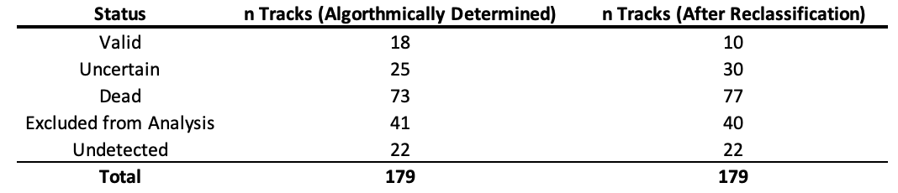

**Table 2: Descriptive metrics of valid tracks from tagged opakapaka**

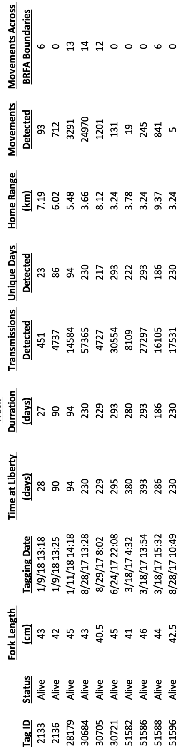

**Figures**

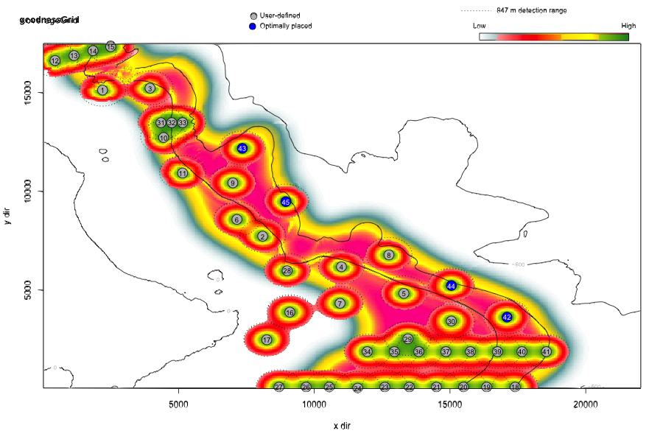

Figure 1: Combined outputs from the Acoustic Web App showing the coverage of the receiver array in BRFA-E and the surrounding study site. Positions of each receiver station (grey numbered circles) and the probability of detecting a tag at range (heat colored circles around each receiver) relative to adult bottomfish habitat between the 100 and 400-m bathymetric contours (pink-teal heat map swath, where pink represents habitat areas of high quality). Note that receiver numbers assigned by the Acoustic Web App are arbitrary and do not correspond to the station IDs referenced below.



Figure 2: Chart showing the station array deployed during FY2018. The boundaries of BRFA-E are shown by the purple bounding box. Solid red circles show receiver stations that were successfully deployed, recovered, and downloaded. Open red circles show stations that could not be recovered (station loss, data failure). Adult bottomfish habitat (100-400 m) is highlighted in light blue.

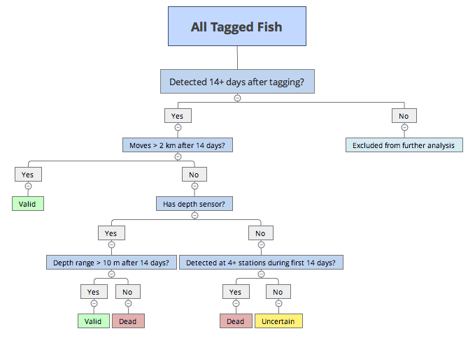

Figure 3: The FY2018 mortality decision algorithm that was used to classify each tagged fish from their detection record.



Figure 4: Orange bars show the distribution of fork lengths for tagged P. filamentosus with valid tracks and blue bars indicate all P. filamentosus tagged during the duration of the project (top). Simulation results show that the observed distribution mean for fork lengths of fish with tracks classified valid (blue line) fell outside the range expected from the total population data (middle), the observed standard deviation of the distribution (blue line) was also smaller than would be expected if survivorship was random (bottom).

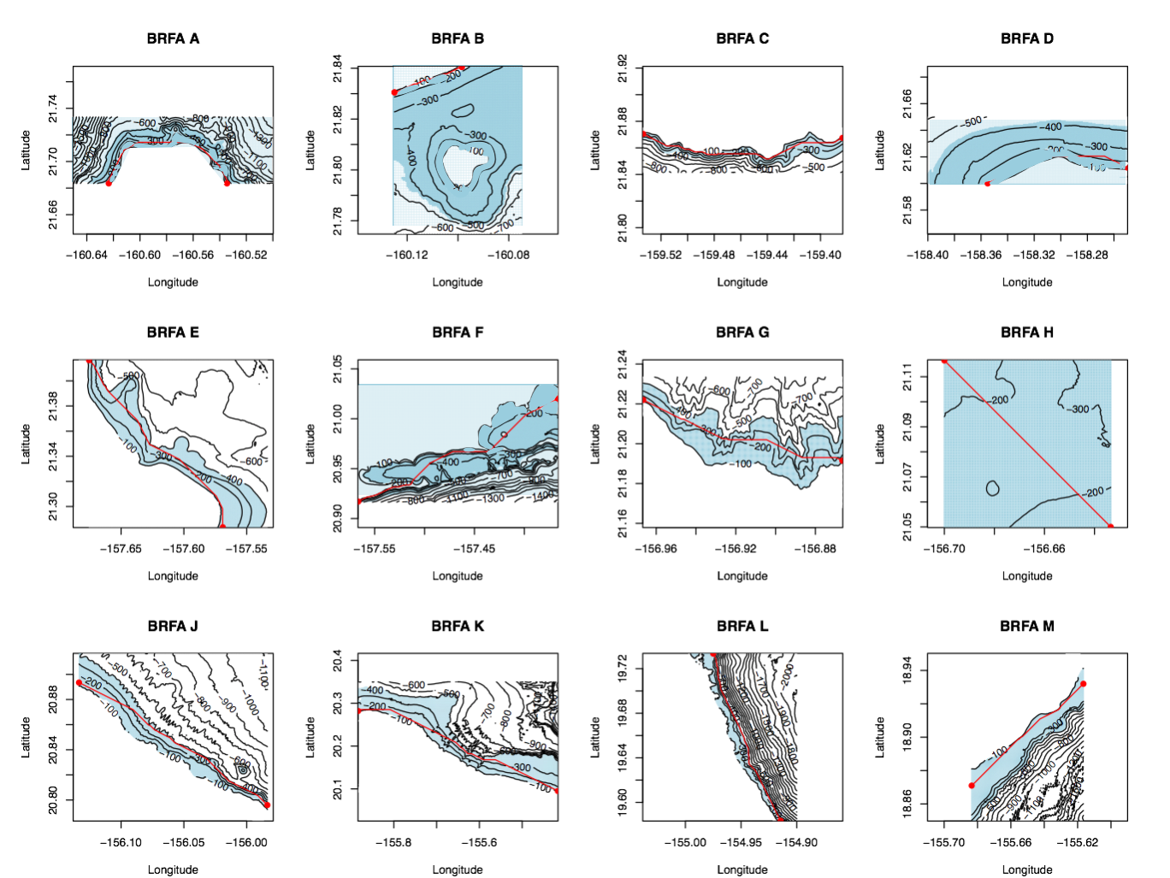

Figure 5: Maps of the 12 BRFAs used to calculate their linear habitat dimension. BRFA Boundaries correspond to the boundaries of each plot. The least cost path approach calculated the distance across the BRFA starting and ending at the 120-m contour. The blue highlighted area indicates the 100 – 400-m depth range used to constrain each path. The red line shows the shortest (least-cost) path through the BRFA.



Figure 6: Comparison of the maximum movement distances observed for P. filamentosus (Valid tracks only) to the linear habitat dimensions of the 12 BRFAs



*Figure 7: Comparison of depths by period of day for the 10 valid opakapaka tracks. (a) Observed depths were available for two fish tagged with V13P tags. (b) For all 10 tags, depth was also inferred using depth of the receiver at which a detection occurred as a proxy for fish depth.*



Figure 8: Mean location of individuals with significant diurnal movements. Pink, green, and blue points represent individual mean positions during dawn, day, and night periods respectively. These fish were not detected on the array at dusk and therefore their mean position during this period is uncertain. Hollow red circles indicate the location of receivers and the purple bounding box is the border of BRFA E.







1. Harding, K. 2018. Personal commun. State of Hawaii Department of Land and Natural Resources Division of Aquatic Resources, Honolulu, HI
2. Mention of trade names or commercial companies is for identification purposes only and does not imply endorsement by the National Marine Fisheries Service, NOAA.